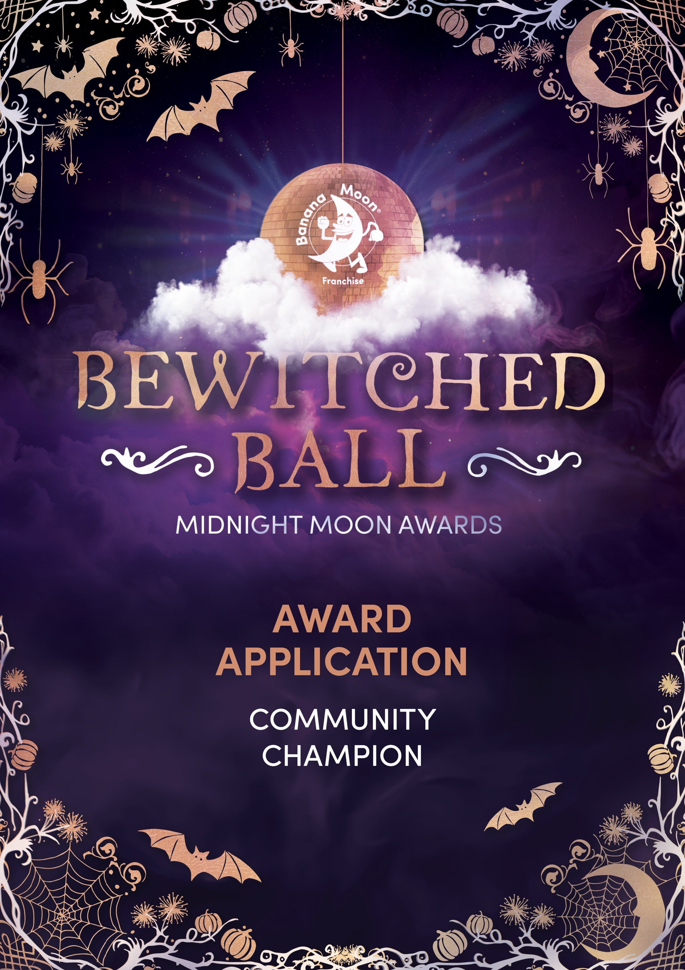
Once you’ve completed your application, please email it to events@bananamoonfranchise.com by 31st July 2026.

Please provide clear examples of your impact on the local community.
Type your response here.
Include testimonials from the community.
Type your response here.

Please include photographs showcasing your community work below.

