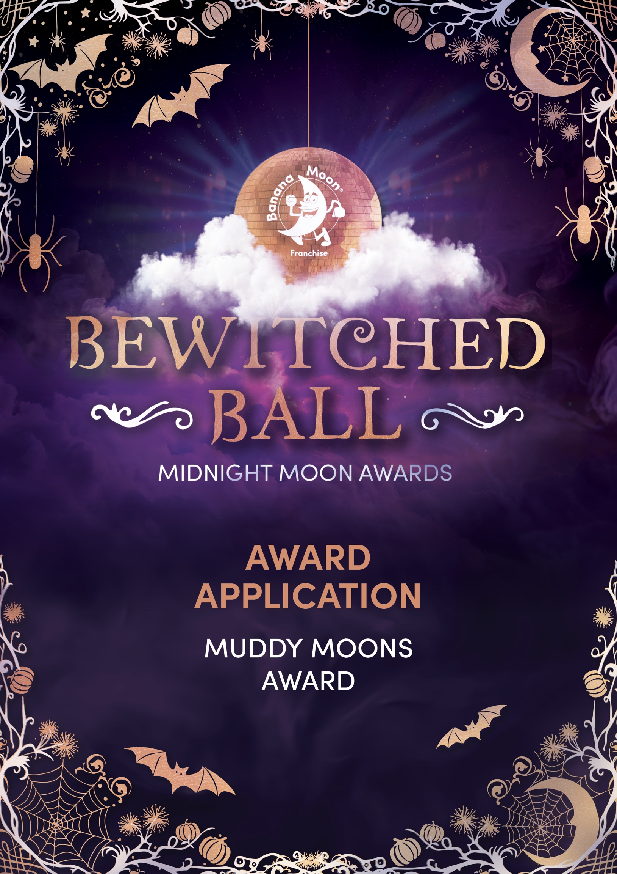
Once you’ve completed your application, please email it to events@bananamoonfranchise.com by 31st July 2026.

Provide a summary of why you feel the outdoor play in your nursery stands out from others.
Type your response here.
What CPD opportunities have your staff been given with regards to outdoor play?
Type your response here.

Summarise how you embed the Big Play, Little Play approach.
Type your response here.

Provide staff testimonials regarding how the CPD journey and ethos of Muddy Moons has had a positive impact on their practice.
Type your response here.

Please include photographs showcasing the ELDP being implemented for all ages in your outdoor areas/gardens.

