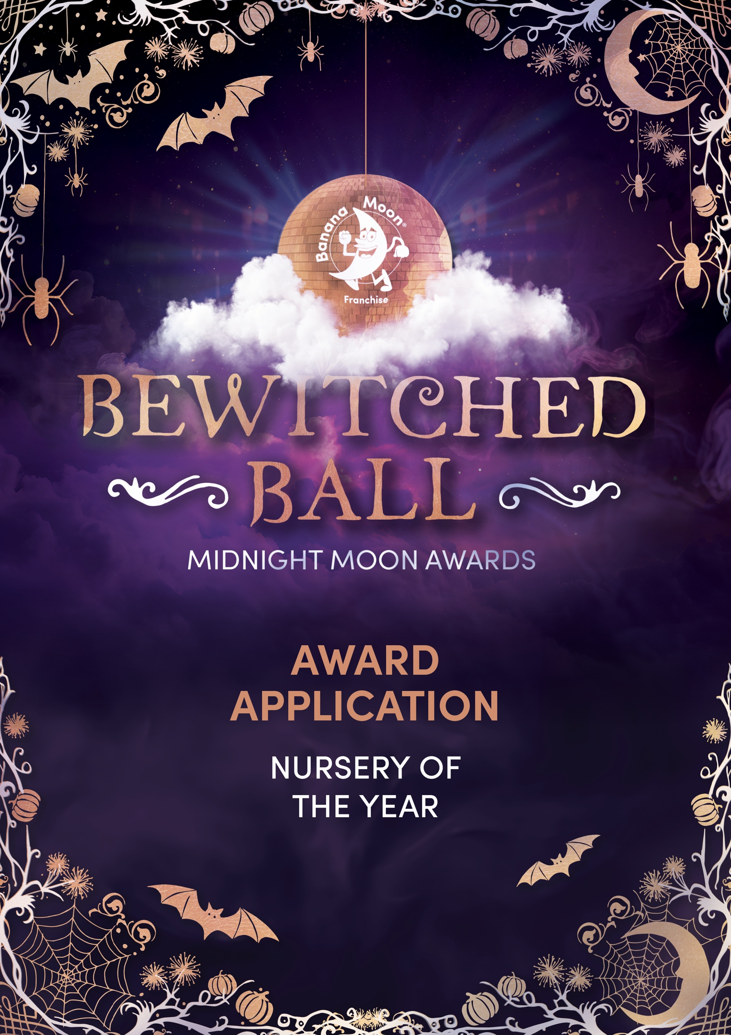
Once you’ve completed your application, please email it to events@bananamoonfranchise.com by 31st July 2026.

Help us create a detailed picture of daily life for every child in your nursery by providing a thorough description of their typical day.
Type your response here.
Please share testimonials from staff, families, and if possible, children in your nursery.
Type your response here.

Share what makes your nursery unique compared to others.
Type your response here.

Provide a summary of the recognitions you’ve received from other external organisations
Type your response here.

Summarise your most recent regulatory body inspection and Banana Moon audit scores.
Type your response here.

In order to assess brand compliance, please summarise how you meet and promote the Banana Moon brand.
Type your response here.

Please include photographs showcasing the ELDP in action below.

